**Films assignment**

**Find all the information about each film**

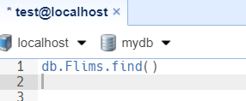

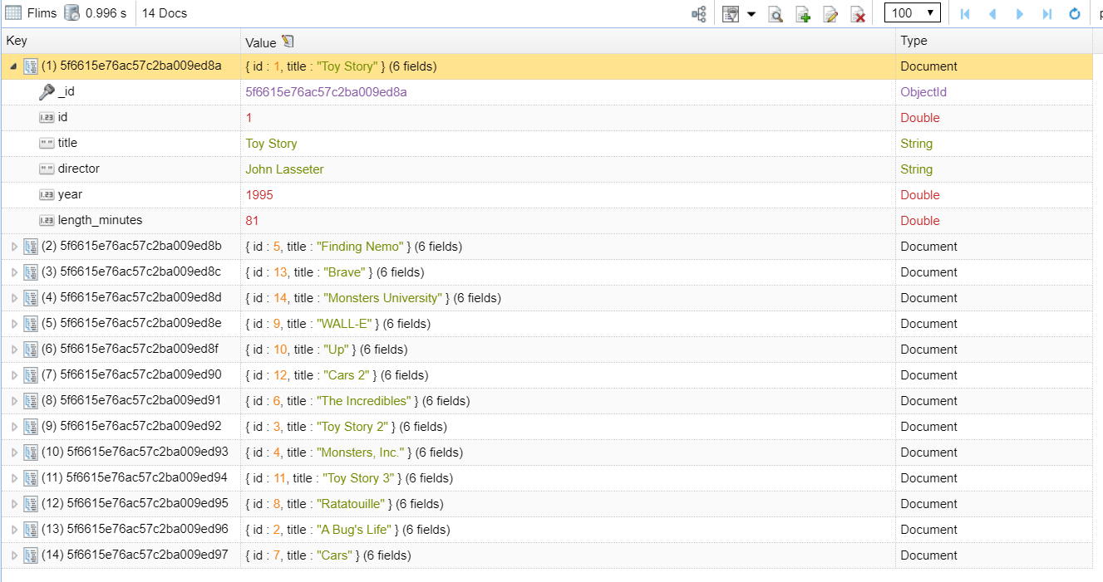

**Find the title of each film director**

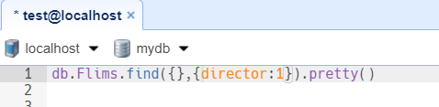

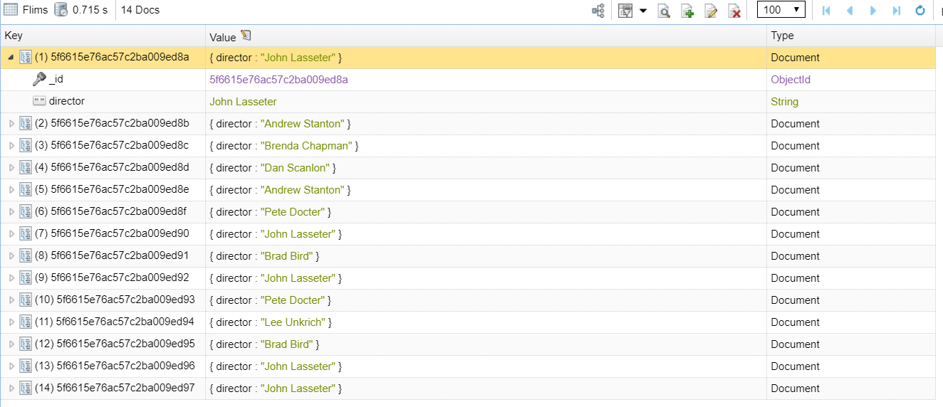

**Find the title of each film title**

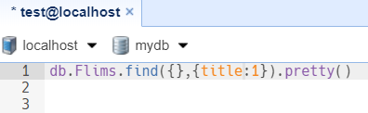

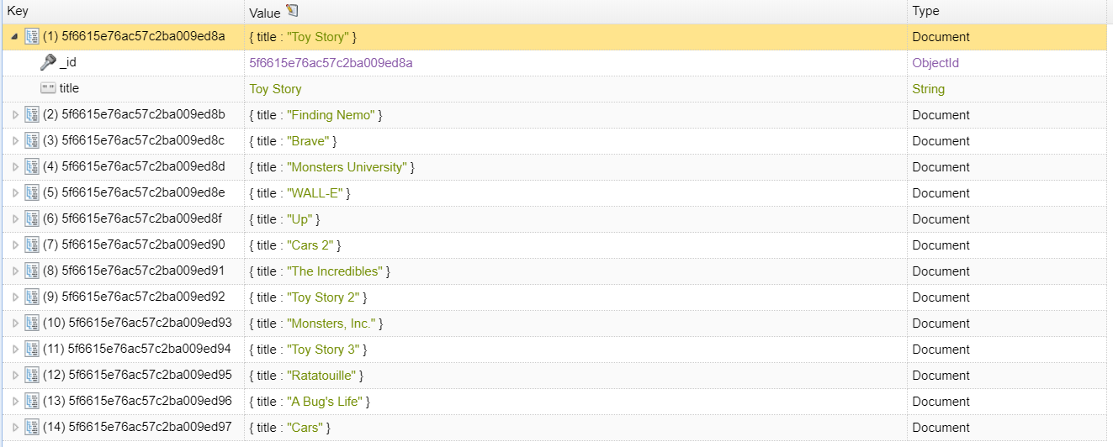

**Find the title of each film title and director**

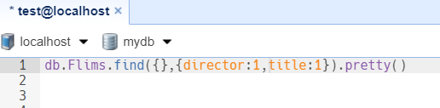

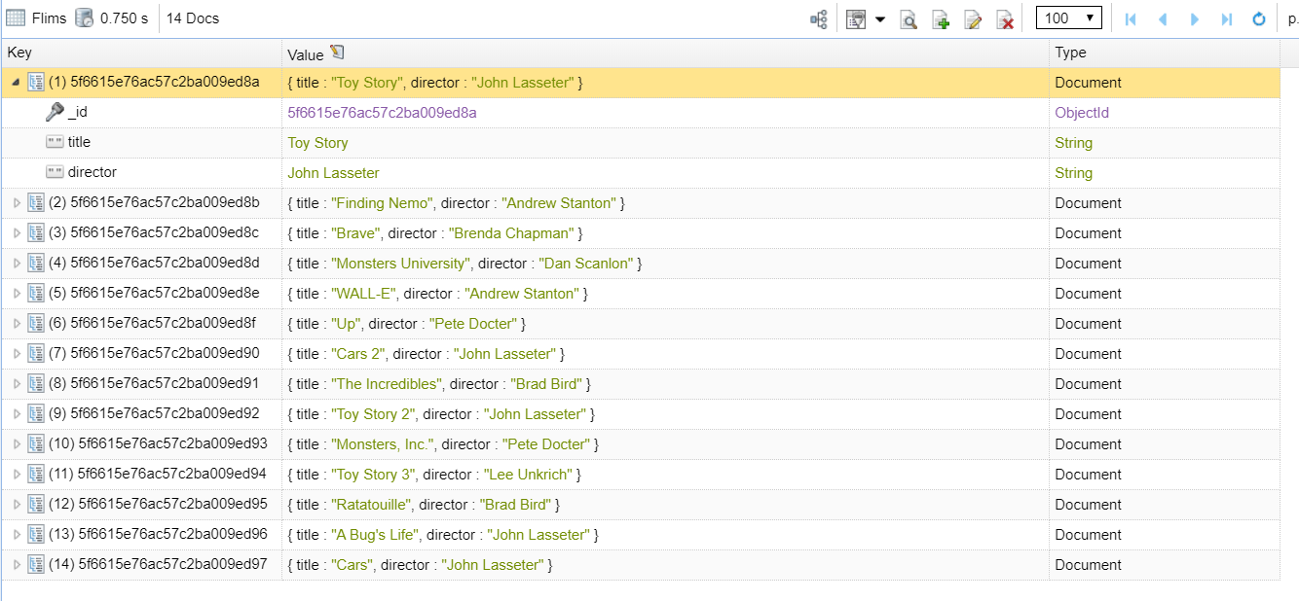

**Find the title and year of each film**

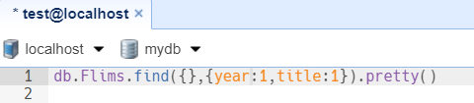

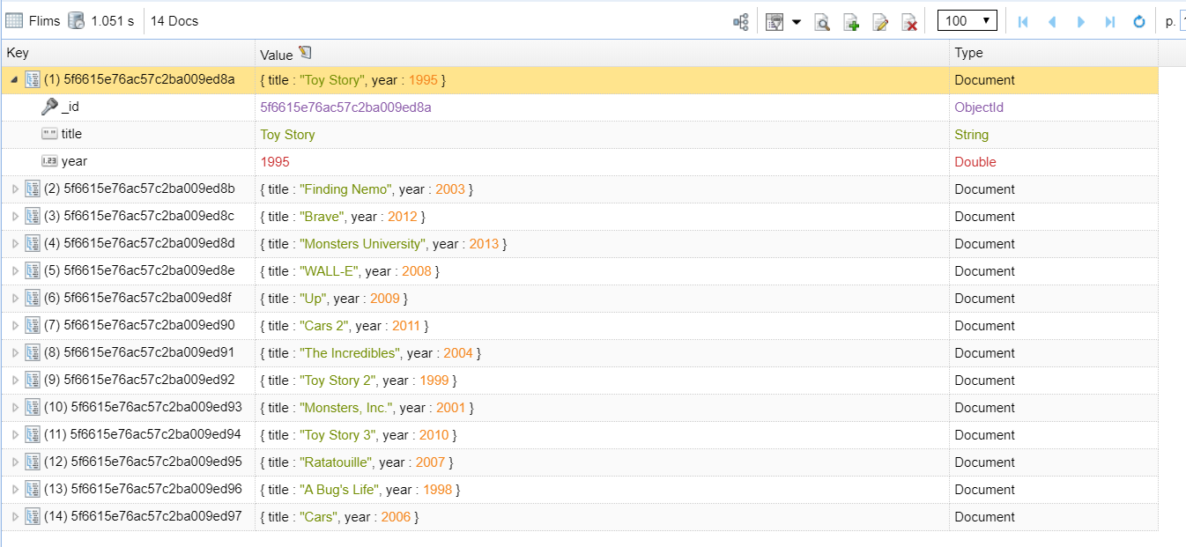

**Find the movie with a row id of 6**

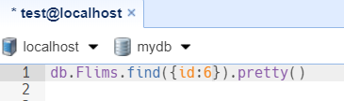

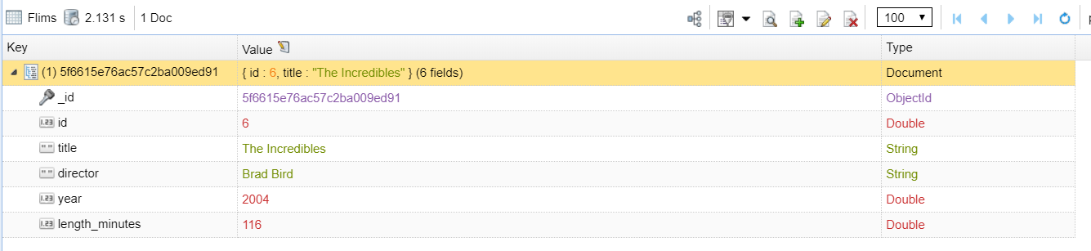

**Find the movies released in the years between 2000 and 2010**

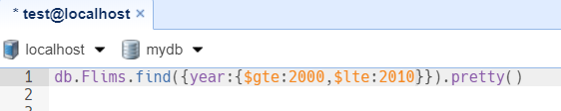

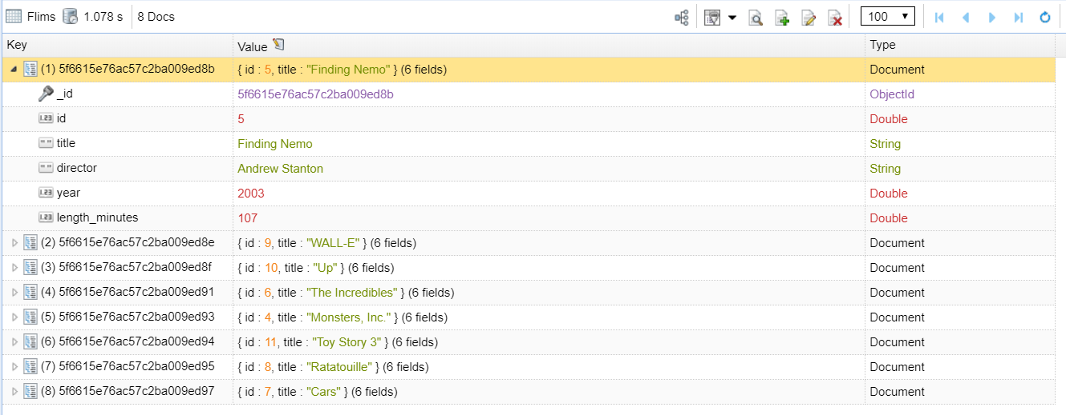

**Find the movies not released in the years between 2000 and 2010**

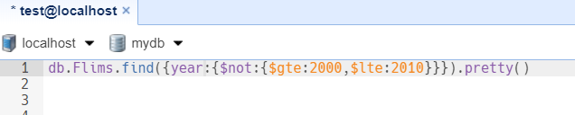

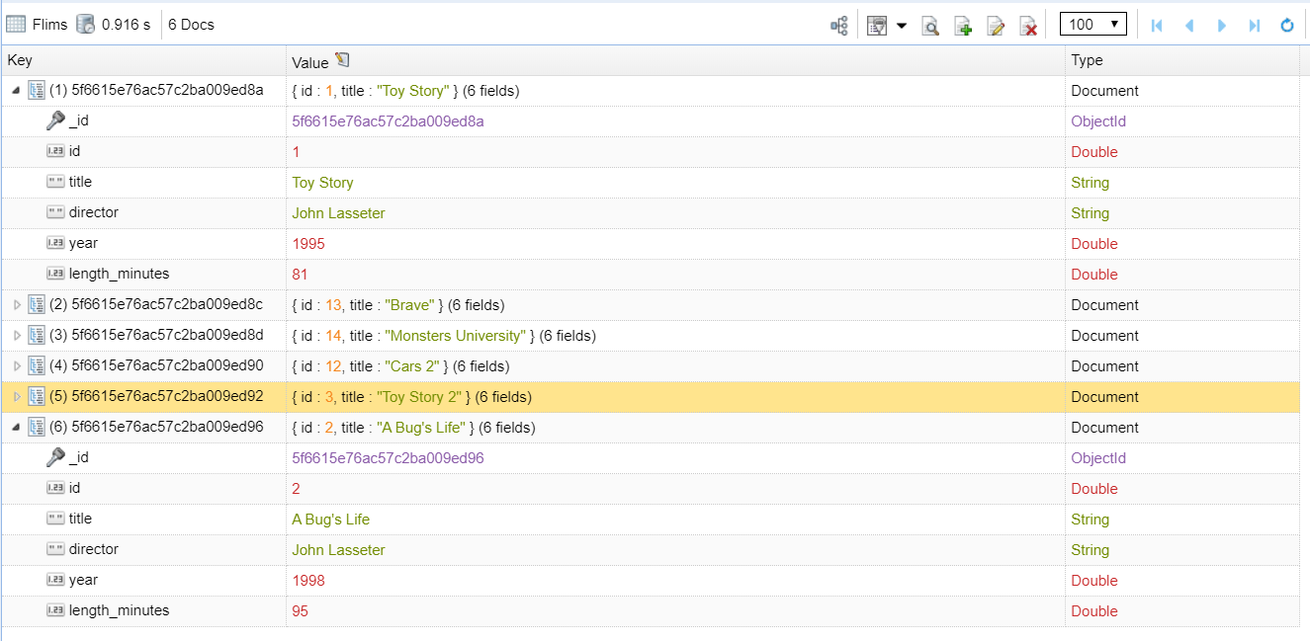

**Find the first 5 Pixar movies and their release year**

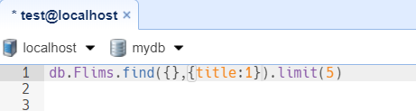

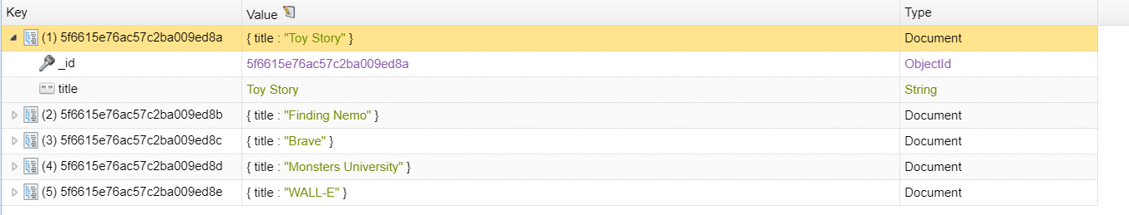

**Find all the Toy Story movies**

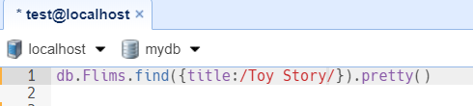

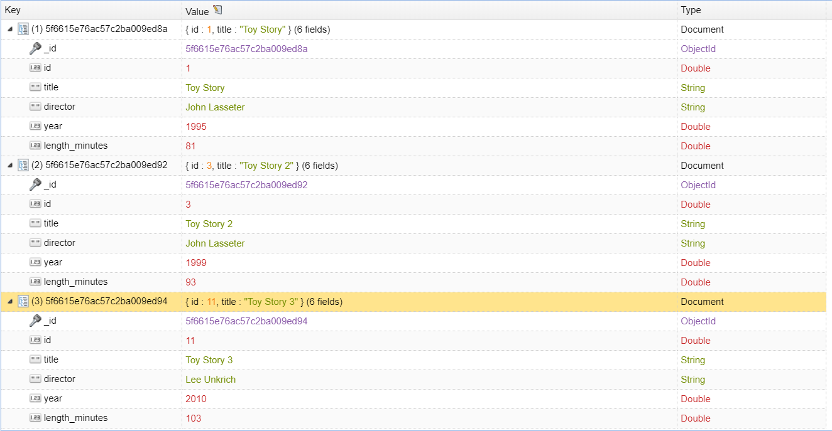

**Find all the movies directed by John Lasseter**

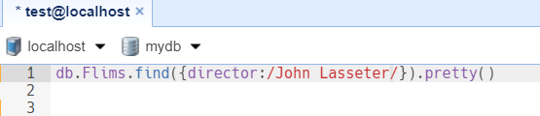

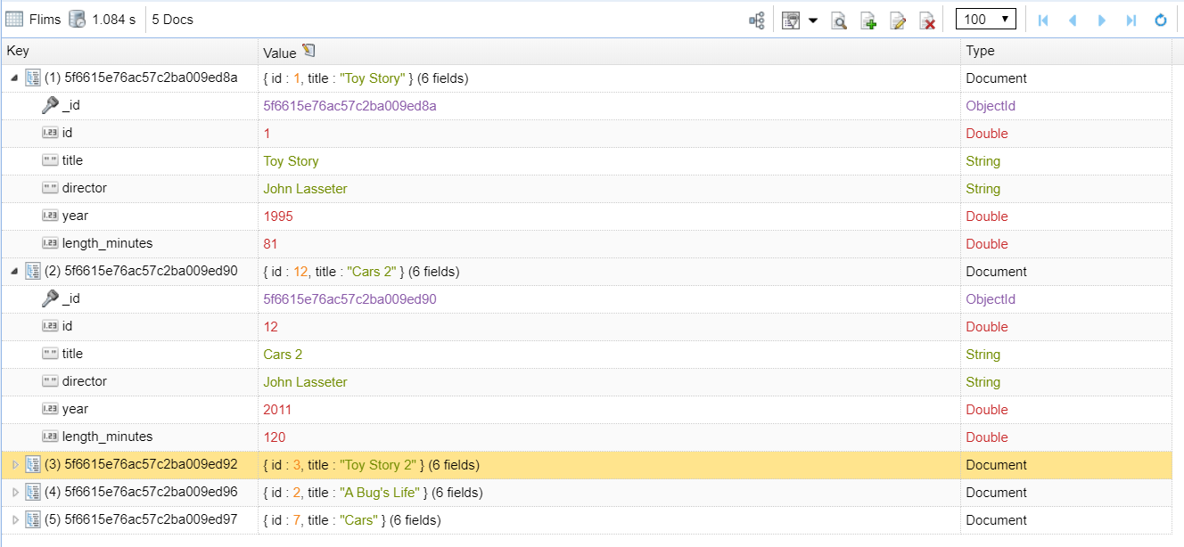

**Find all the movies (and director) not directed by John Lasseter**

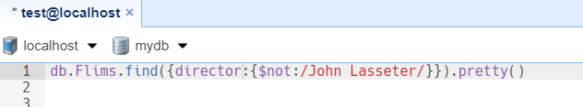

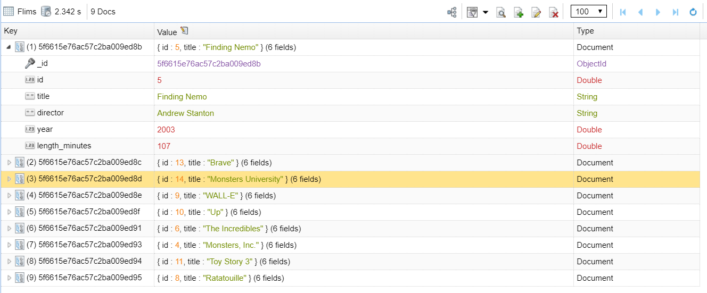

**Find all the WALL-* movies**

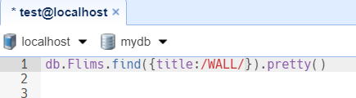

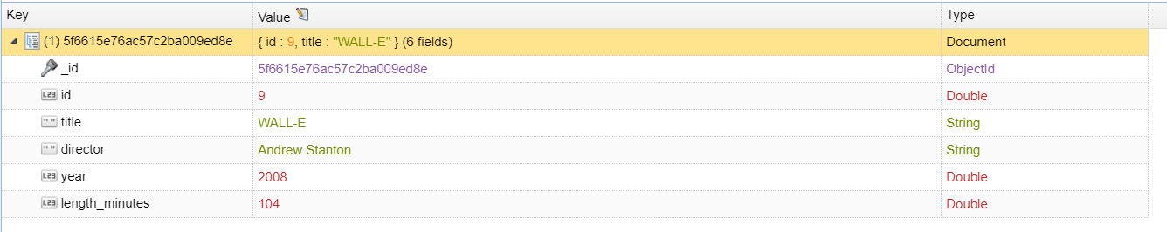

**List the last four Pixar movies released (ordered from most recent to least)**

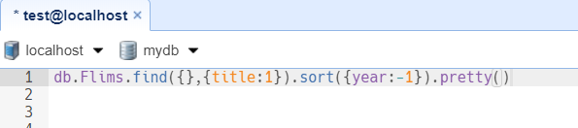

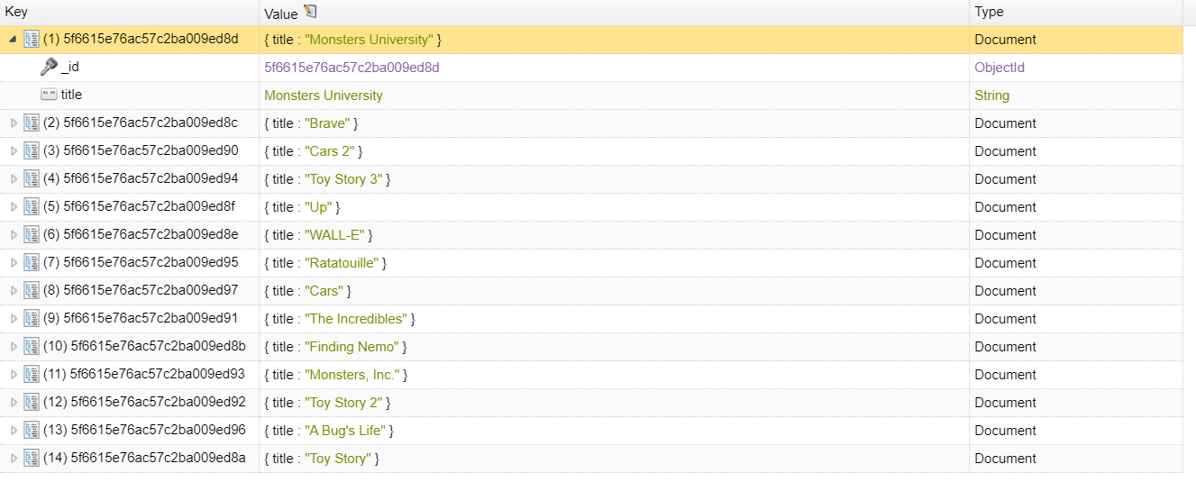

**List the first five Pixar movies sorted alphabetically**

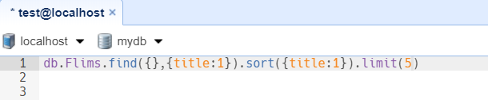

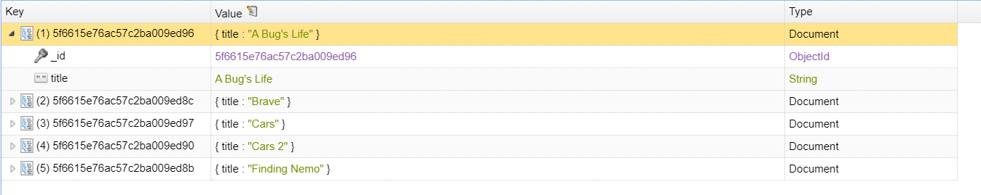

**List the next five Pixar movies sorted alphabetically**

